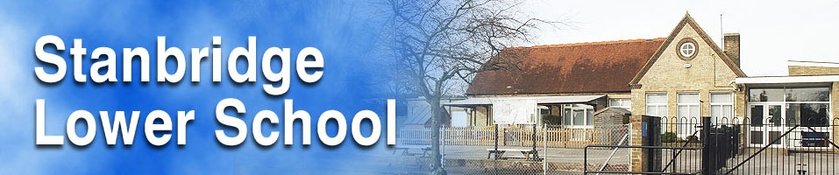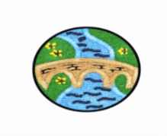

**History**

* Go on a question hunt to learn what WW2 was and why it happened
* Watch videos and examine pictures to research what the Blitz was and where was likely to be affected
* Research the effects of air raids and causes of evacuation using the library
* Explore the feelings and experiences of evacuees by writing letters home
* Explore rationing by comparing wartime party foods to modern day
* Discuss and research how people’s everyday lives were affected by the war

**Geography**

* Explore lines of latitude and longitude, and use these as coordinates to find locations in an atlas

**Science**

Electricity

* Classify appliances using Venn diagrams
* Explore different electronic equipment such as bulbs, switches, wires etc. to create circuits
* Investigate whether circuits will work or not and explore why
* Investigate which materials conduct or insulate against electricity
* Build and test switches in circuits
* Build a working circuit to use in our DT project to build an Anderson Shelter

**PSHCE**

Living in the Wider World: Rights and Responsibilities, Taking Care of the Environment, Money

* Debate as a class some topical health initiatives, such as Change 4 Life, giving children the chance to share their opinions and value those of others
* Explore what human rights everyone has, and particularly them as children
* Discuss and explore the different rules and laws people follow and why these are important
* Explore the differences between a responsibility, a right and a duty, and which of these children might have
* Children will discuss and investigate what antisocial behaviour is, and how we can prevent it and what we should do about it
* Roleplay different ways to resolve conflict and differences between friends

**Simmering Starter:** Listen to some popular songs from the 1940s.

**Grand Finale:** Re-enact the procedure for an air raid drill in the classroom.

**World War II**

Teacher: Mrs Brewer

Year Group: 4

Academic Year: 2022-2023

**Forest School**

* As part of our celebrations for the king’s coronation, the children will create some natural portraits of the royal family in the style of Giuseppe Arcimboldo, who was a court painter for Emperor Maximillian in Vienna, Austria. He had a fascination for plants, flowers, leaves and vegetables

**Music**

Kapow: Rock and Roll

* Listen to different examples of rock and roll music
* Learn to hand jive
* Identify features of this style of music
* Practise and play a walking bass line on glockenspiels, reading musical notation

**Computing**

E-Safety: Online Bullying, Managing Online Information and Personal Information

* Investigate what cyberbullying is and what we can do about it
* Explore how the things we read online may not always be true, even if lots of people believe it
* Investigate how and why our internet use can be monitored, and what a digital footprint is

Digital Creativity

* Use the internet to research how structures can be strengthened, and how materials can be joined
* Use the internet to research the events of the Blitz

**PE**

Twinkl Move Athletics

* Develop running and sprinting techniques and use these for a sprint finish
* Develop techniques to jump for distance when triple jumping
* Practise different throwing techniques, including the pull throw for javelins

Twinkl Move Dance

* Respond to different stimuli to create movement phrases around water
* Develop ways to link and combine these movement patterns to create a dance
* Perform our water dances with expression

**Art and Design Technology**

* Explore how structures are made and what methods are used for strengthening them
* Research the work of architect Zaha Hadid
* Design, make and evaluate a model Anderson shelter using ideas from research
* Explore works by the artist Andy Warhol, particularly his pop art and examine some of the features of this style of art
* Create a pop art print of WW2 objects in the style of Andy Warhol using inks

**French**

What’s the Time?

* Say and write sentences to tell the time from clock faces including o’clock, half past, quarter past and quarter to
* Create a booklet to describe when we do things during the day
* Read and answer questions about a TV schedule in French
* Interpret and complete a school timetable

**RE**

For Christians, What was the Impact of Pentecost?

* Retell the story of Pentecost through storyboards, and explore the feelings of people involved
* Explore how Christians believe the Holy Spirit helps them
* Explore the idea of the kingdom of God, and how Christians have been trying to make Earth more like it
* Discuss the idea that Pentecost is the Church’s birthday, and how this could be celebrated
* Consider and discuss some alternate viewpoints, including atheism