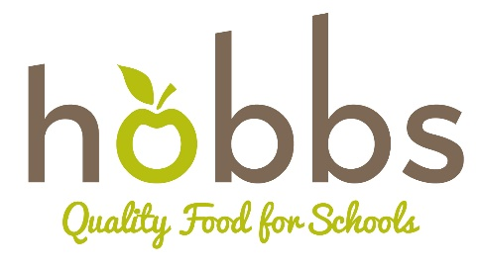

Spring Census Day

18.05.23

*All codes are correct as of 05.04.23 – if you find any discrepancies, please notify us and we will issue new codes
Cheese & Pepperoni Pasta Bake
Contains: Celery, Lactose, may contain traces of Egg and Milk.

Ingredients
- Pepperoni
- Tinned diced tomatoes
- Tomato Puree
- Passata
- Diced onions
- Garlic Puree
- Chicken Bouillon
- Mixed Herbs
- Mild White Cheddar

Ordering

Item | Allergens
Pepperoni | May contain traces of Egg & Milk
Chicken Bouillon | Celery
Tinned Tomatoes | -
Passata | -
Diced Frozen Onions | -
Tomato Puree | -
Garlic Puree | -
Mixed Herbs | May Contain Celery
Mild White Cheddar | Lactose

Cheese & Tomato Pizza (Meat feast Pizza)
Contains: Gluten, Milk (Lactose), may contain Celery, Soya
Please see allergen list below for meat feast pizza

Ingredients
- Plain flour
- Margarine
- Yeast
- Granulated sugar
- Mozzarella cheese
- Onions
- Garlic
- Sunflower oil
- Tinned chopped tomatoes
- Mixed herbs

Ordering

Item | Allergens
Plain Flour | Wheat (Gluten) – May contain Soya
Margarine | Milk (Lactose)
Yeast | -
Granulated Sugar | -
Mozzarella cheese | Milk (Lactose)
Diced Frozen Onions | -
Diced Frozen Peppers | -
Vegetable Bouillon | Celery, Gluten
Garlic Puree | -
Vegetable Oil | -

Meat Feast

Item | Allergens
Sausages | Wheat, Soya, Sulphites
Pepperoni | May contain traces of Egg & Milk
Meatballs – Frozen | Cereals, Soya, may Contain Celery, Milk, Eggs, Mustard
Gammon | -

Lemon Drizzle Cake
Contains: Cereals, Wheat, Eggs, Soya, Sulphites

Ingredients
- Sponge Mix
- Lemon Juice
- Icing sugar
- Fresh lemon juice and rind

Ordering

Item | Allergens
Sponge mix | Cereals, Milk, Eggs, Soya
Lemon juice | Sulphites
Granulated Sugar | -
Icing sugar – 1kg | -
Lemons (fresh) | -

Ice Cream
Contains: lactose

Ingredients
- Individual ice cream tubs

Method
- Please feel free to order either strawberry or Vanilla.

Ordering

Item | Allergens
Strawberry | Lactose
Vanilla | Lactose

