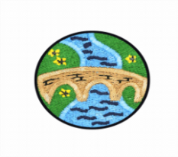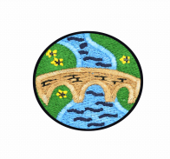

Teacher: Mrs Turney

Year Group: 3

Academic Year: 2022/23



**Around the World**

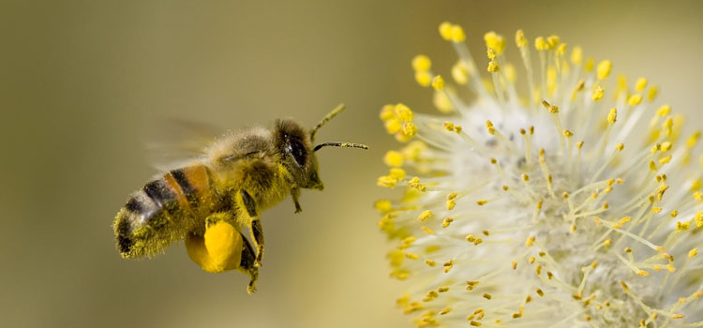

**Grand Finale:**

A fantastic display of the children’s

art work and sewing, plus all the plants we have

grown and our blossoming bee garden.

**Simmering Starter:**

The children will make a ‘Bee Garden’ out of recycled materials. They will then plant a selection of ‘bee friendly’ plants and flowers to try and attract bees and other insects.

**Geography**

This half term our focus in Geography is Leighton-Linslade’s twin town in France ‘Coulommiers’.

We will explore the town and area in France and then the children will go on to compare and contrast key aspects of human geography settlements, land use, economic activity, trade links and natural resources.

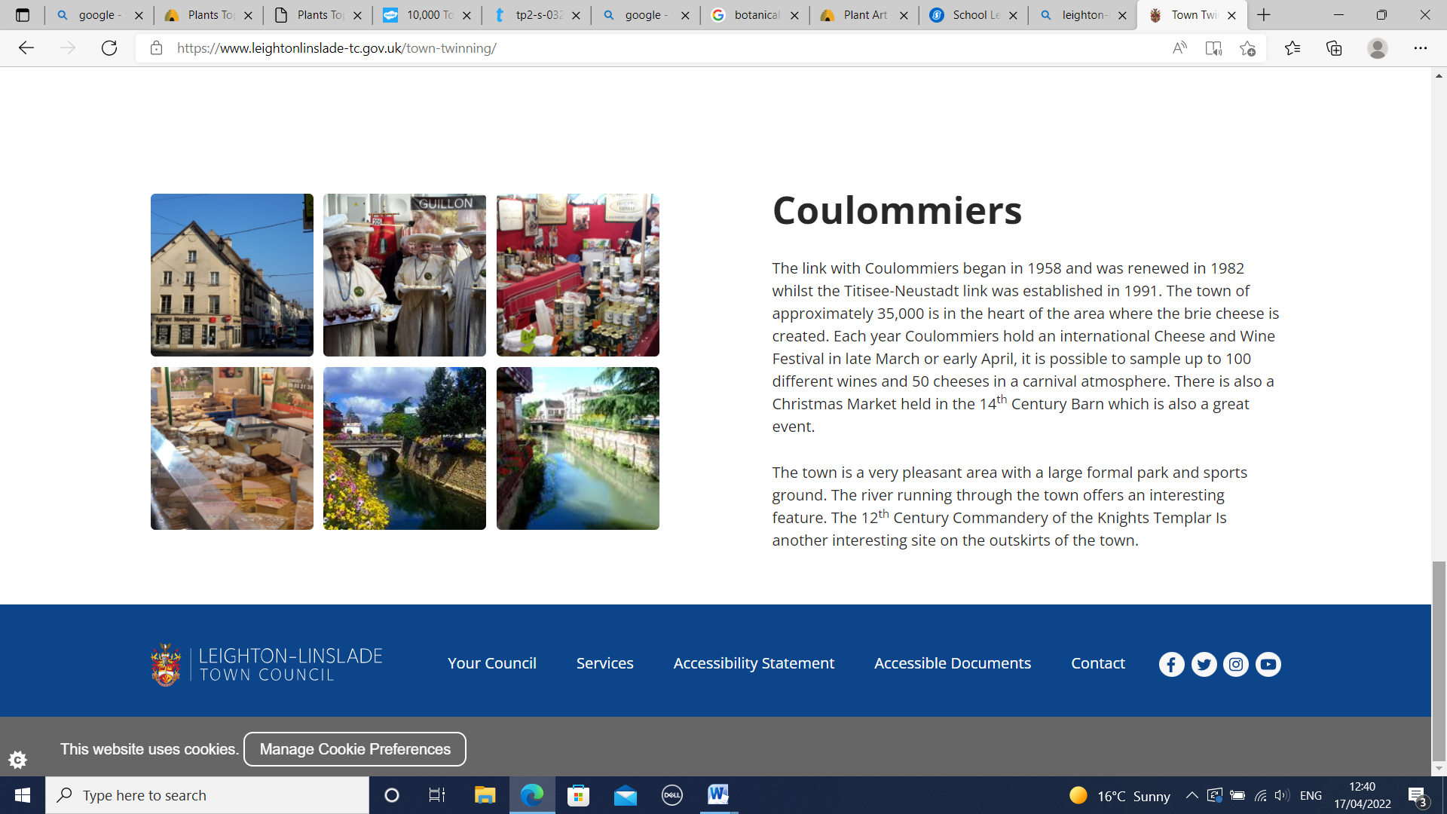The

**Science**

During this ‘Plants’ unit children will learn the names of different parts of plants, and the jobs they do. They will work scientifically and collaboratively to investigate what plants need to grow well, and will present their findings to their classmates. Furthermore, they will have chance to predict what will happen in an exciting investigation into the transportation of water within plants. They will work in a hands-on way to identify the parts of a flower, and will explore the different stages of the life cycle of a flowering plant.

Children will be able to:

•Explain the functions of the different parts of plants.

• Set up an investigation and make predictions.

• Make observations and conclusions.

• Identify different parts of a flower.

• Identify and describe the stages of the life cycle of flowering plants.

• Be able to answer questions based on their learning.

**Art**

**‘Plant Art’**

This half term we will be exploring different art using plants as our theme.

Children will:

•Evaluate and comment on the artwork of others.

•Explore and complete botanical drawings.

•Learn how to mix and different tints, shades and tones in flower artwork.

•Learn how to create the illusion of depth through tree-based artwork.

•Create flower-themed sculptures using clay.

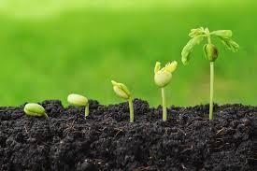

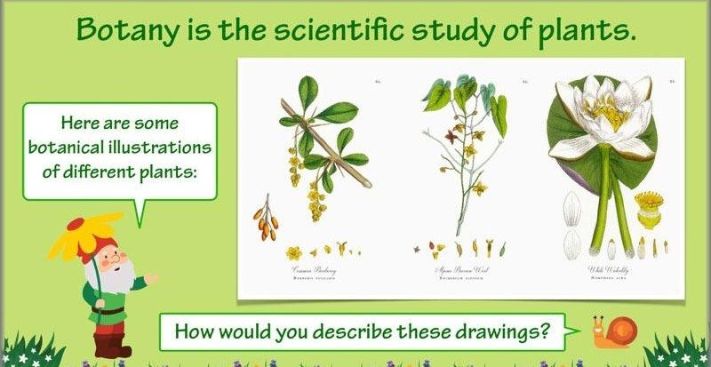

**Design Technology**

This half term the children will be sewing and taking part in cookery lessons.

In our sewing lessons they will design, assemble and sew a 3D felt bee or flower decoration which will encourage their creativity and allow them to experience using a variety of materials, joining techniques and tools.

Our cookery lessons will focus on:• Healthy eating • Consumer awareness • Food and hygiene safety

**PSHCE**

The children will look at the role of rights and responsibilities in our society. They will explore children’s rights, find out how to be good citizens and look at expected standards of behaviour within this.

**RE**

The children will be learning about the Holy Trinity and making links with this between religions. They will represent thoughts and feelings through art and look at the work of David Bonell. They will look at the role of baptism in the Christian faith.

**French**

**‘Friends and Family’**

During this unit children will learn how to identify and introduce family and pets.

Children will be able to:

• identify and introduce some of their relations;

• name some common pets;

•recognise the sounds of the alphabet in French.

**Music**

This half term the children will be exploring jazz music.

They will be learning about:

* Ragtime style music
* Dixieland music
* Scat singing



Children will create a jazz motif using a swung rhythm and play a jazz version of a nursery rhyme using tuned percussion.

**PE**

**Dance**

The children will learn a range of different dance techniques with the aim of producing an interesting and varied dance phrase to represent the water cycle. In each session the children will explore a different stage of the water cycle and will practice and apply dance techniques.

**Athletics**

In these Athletics lessons, children will have the opportunity to develop their existing running, jumping and throwing skills. They will be learning about an effective sprint technique including sprinting over obstacles. The children will be given opportunities to use a variety of throwing techniques, including the underarm and overarm throw to throw for both distance and accuracy. They will learn the technique for throwing the shot put (push throw) and how to do the standing long jump. Throughout the unit, they will be encouraged to try and achieve their personal best and will be working independently, in pairs, as well as collaboratively within a group.

**Forest School**

As part of our celebrations for the king’s coronation, the children will create some natural portraits of the royal family in the style of Giuseppe Arcimboldo.

Giuseppe Arcimboldo was a resident court painter for Emperor Maximillian in Vienna, Austria. He was an artist with a fascination for plants, flowers, leaves and vegetables and he produced a set of ingenious portraits for the royal family.

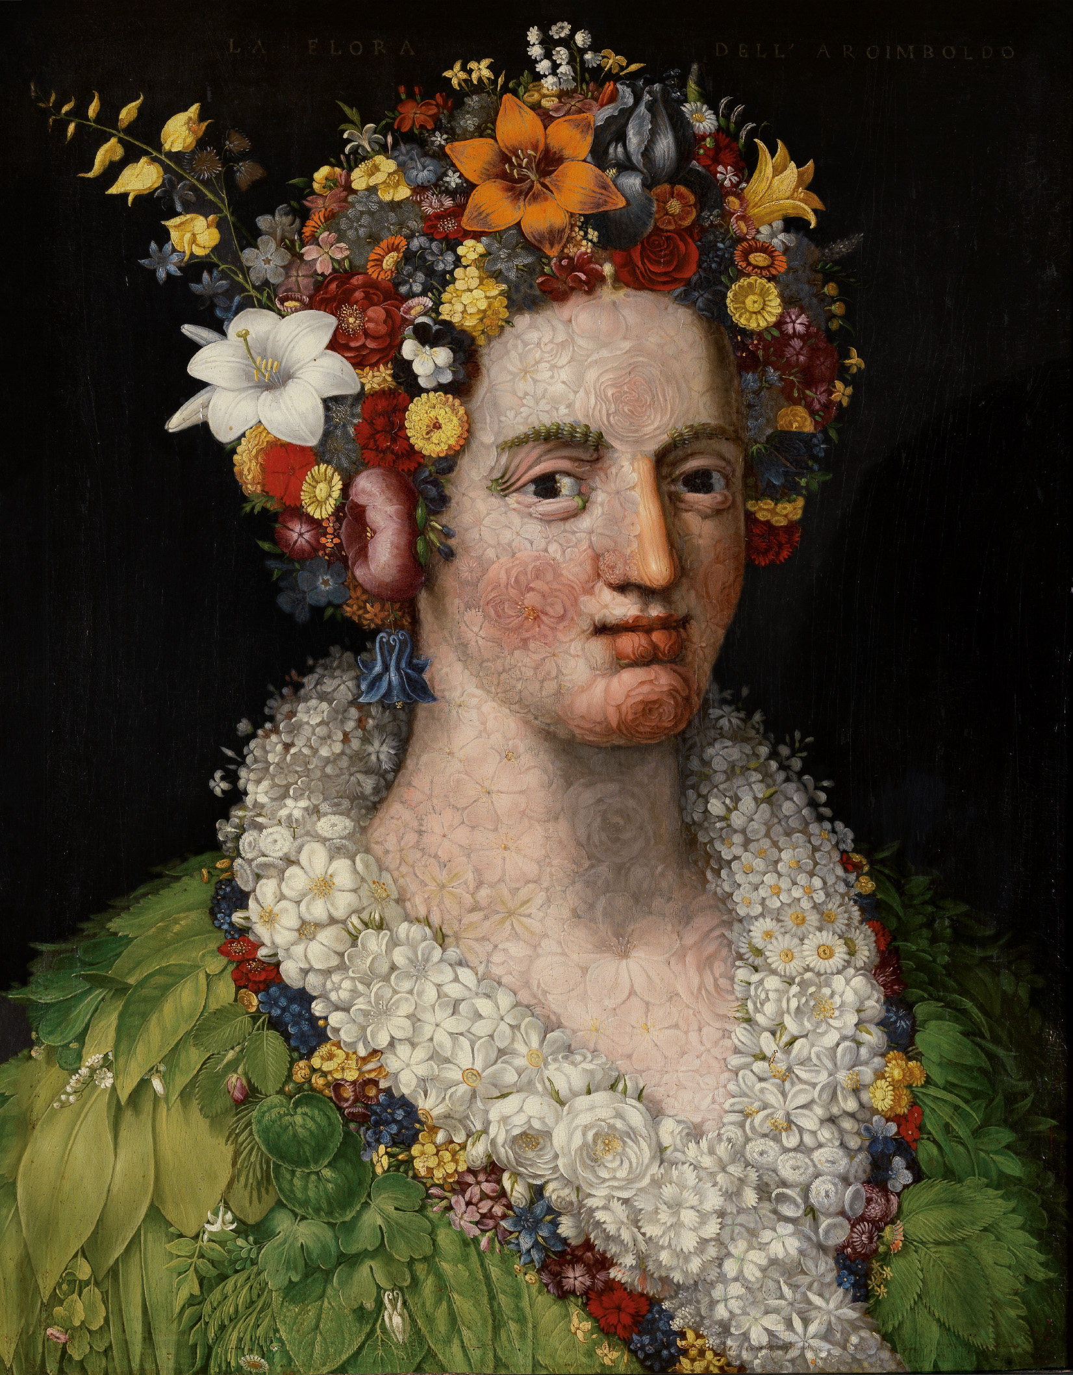

We look forward to sharing our artwork with you soon!

