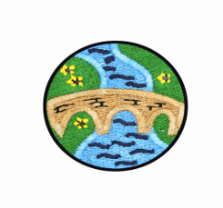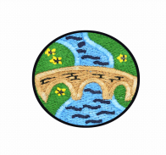

[Type a quote from the document or the summary of an interesting point. You can position the text box anywhere in the document. Use the Text Box Tools tab to change the formatting of the pull quote text box.]

Teacher: MrsTurney

Year Group: 3

Academic Year: 22/23



**Extreme Weather**

**PE**

This ‘**Dance - Extreme Earth**’ unit will teach children a range of different skills linked to the art of dance with the aim of producing an interesting dance phrase to represent a montage of natural disasters. In each session children will explore different areas linked to 'Extreme Earth', including different forms of natural disaster and the effects they have upon people and the world. The children will learn to use improvisation; design their own dance moves; link and combine movements; perform with expression; respond to different stimulus and create and perform a dance phrase applying their newly developed skills. They will develop their skills of co-operation, working both in pairs and small groups to create these movement phrases.

**Grafham water Trip** – A fun filled few days doing lots of different activities such as climbing, sailing, bushcraft, archery, low/high ropes and orienteering.

**Swimming:**

**·** Learn the skills for different strokes

· Use a range of strokes, including front crawl, breaststroke and backstroke, effectively

· Swim competently and confidently for at least 25m

· Perform safe self-rescue in different situations

**Grand Finale:**

The children will perform their ‘Extreme Earth Dance’ in assembly.

**Simmering Starter:**

A drone’s view of an amazing volcanic eruption [Iceland volcano: Drone footage captures stunning up-close view of eruption - YouTube](https://www.youtube.com/watch?v=b9Hq6bTBF2A)

**Science**

Our science lessons this half term will be about **light, reflections and shadows**.

The children will learn about different sources of light, and that we need light to see. They will work scientifically and collaboratively to investigate reflective materials, in the context of designing a new product.

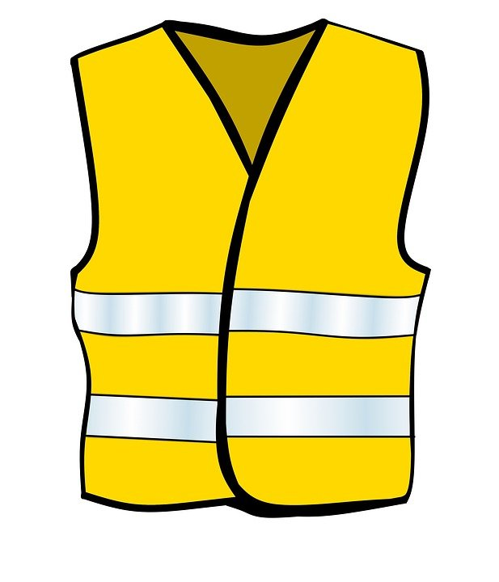Furthermore, they will learn that the sun’s light can be dangerous, and will create an advert for a pair of sunglasses or a sun hat that they have designed.



The children will have chance to test which objects are opaque in an exciting investigation to design the most effective curtains, and will find out how shadows change when the distance between the object and light source changes. They will develop their scientific enquiry skills, making observations, predictions and conclusions.

**Art**

The historical significance of the eruption of Mount Vesuvius influenced art and inspired many artists. This half term, children will study these artworks depicting volcanoes in more detail:

* ‘Vesuvius in Eruption’, (1774), by Joseph Wright;
* ‘The Eruption of the Southfriere Mountains in the Island of St. Vincent, 30th April 1812’, (1815), by JMW Turner;
* ‘An Eruption of Mount Vesuvius’, (1839), by Clarkson Frederick Stanfield;
* ‘Aratame’, (1853 - 1857), by Utagawa Hiroshige;
* ‘Vesuvius’, (1985), by Andy Warhol.

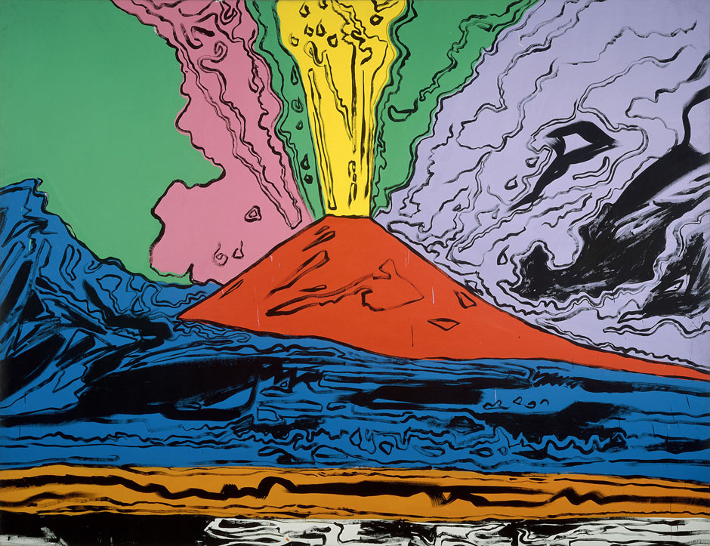

**Geography**

This term the children will look at **extreme weather such as volcanoes and earthquakes**.

The children will study the destructive powers of nature with a closer look at earthquakes and volcanoes. Through discussion and practical tasks, children will learn about how and why these natural phenomena occur, and the ways in which they affect people and the environment.

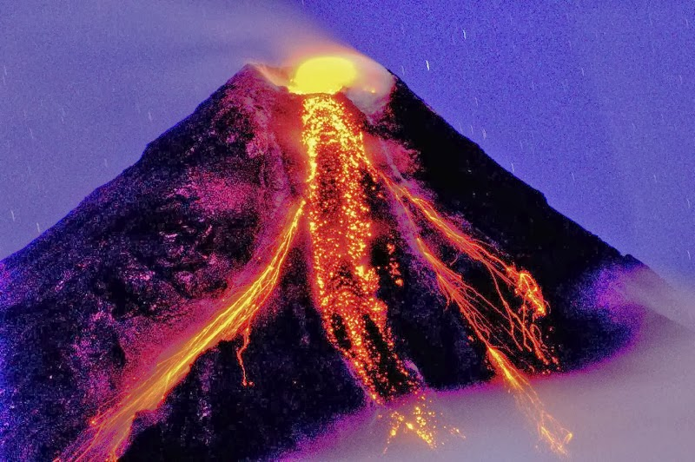

**Music**

This term the children will continue to enjoy lessons delivered by Inspiring Music Combined Project programme teaching ukulele.

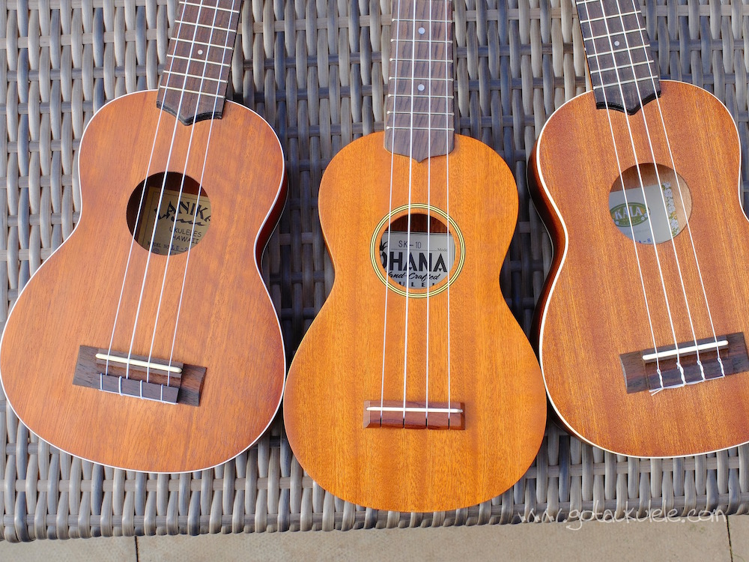

**French**

This term our French lessons are continuing on the theme of **food.** The children will learn how to describe food by colour and size. Once they are confident doing this we will look at engaging children in conversations with each other.

They will learn to:

* ask and answer questions;
* express opinions and respond to those of others;
* seek clarification and help in the context of preparing, eating and talking about food.

To make these lessons even more fun the children will be helping to prepare real food examples from the ‘Le chien très gourmand’ story and they will then have a chance to taste them.

**ICT & Computing**

In this unit, children are introduced to email and other forms of online communication. They will look at how to write and send emails, as well as how to decide if an email is safe to open.

They will also build on their existing knowledge of cyber bullying and how to deal with unkind behaviour online.

The use and importance of privacy settings is introduced and children will discuss the types of information we should not share online. They will build on the idea of a digital footprint by thinking about how the adverts they see online are targeted at them.

**RE**

**PSHCE**