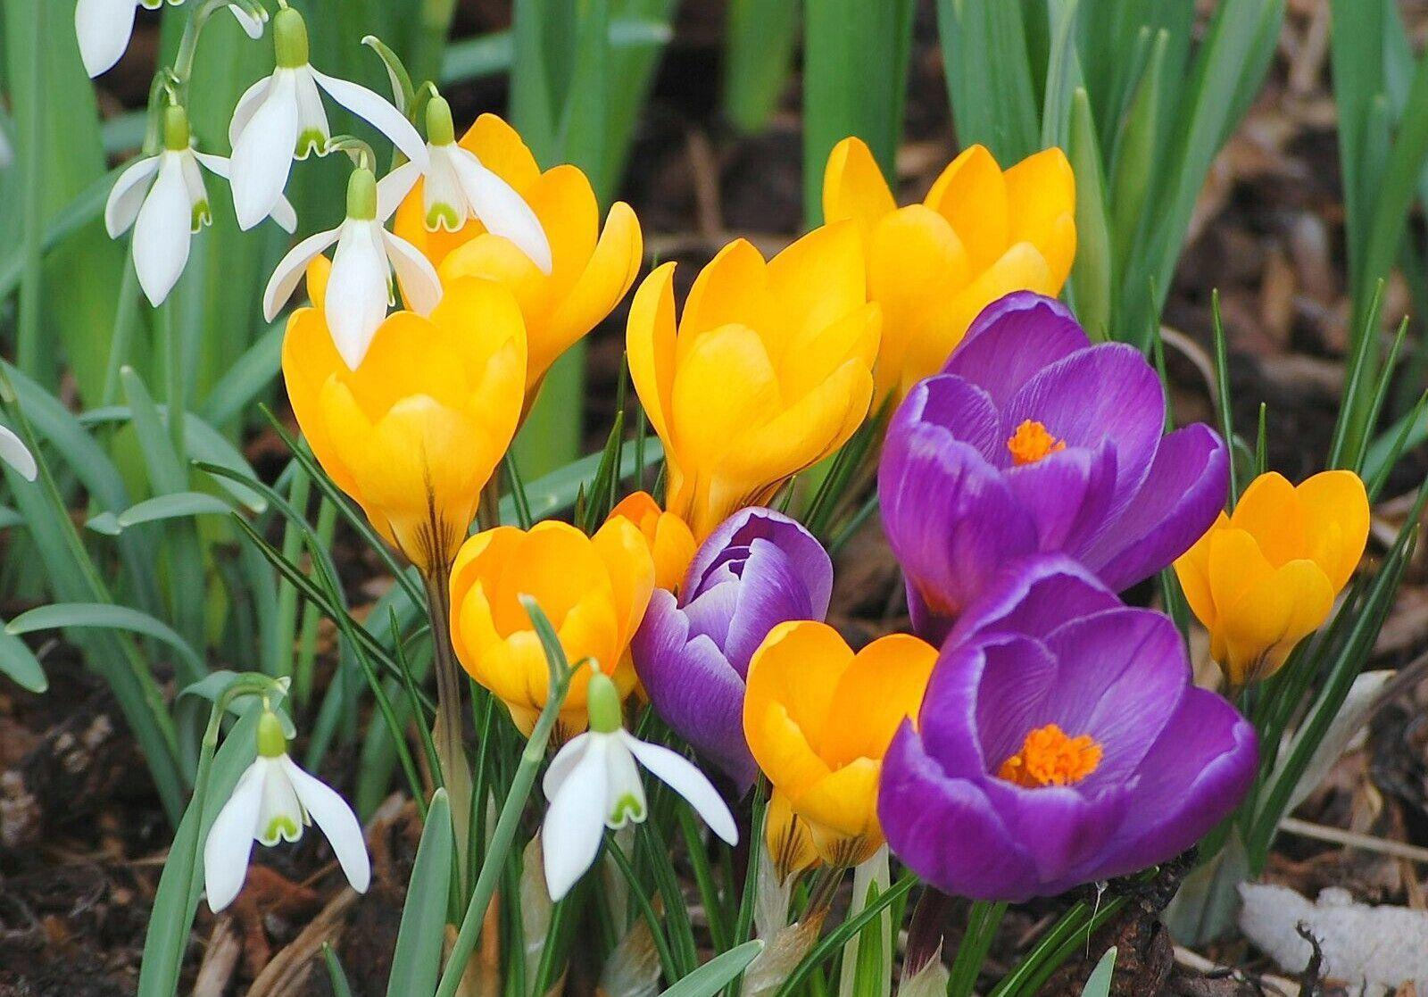

Sketch flowers you might have in your garden or house.

Write a sentence about Spring time. Use your phonics to help you by saying the words out loud and hearing the sounds in them. Write your letters neatly.

**Home Learning Wednesday 15th and Thursday 16th March 2023.**

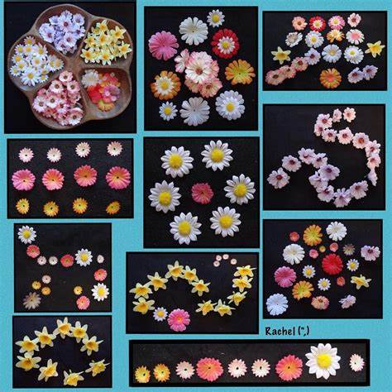

Go on a walk and look out for signs of Spring.

Maths – Making repeating patterns. Draw petals or flowers to make your own repeating pattern.

Practice your number bonds to 5 and 10.

