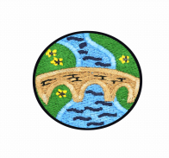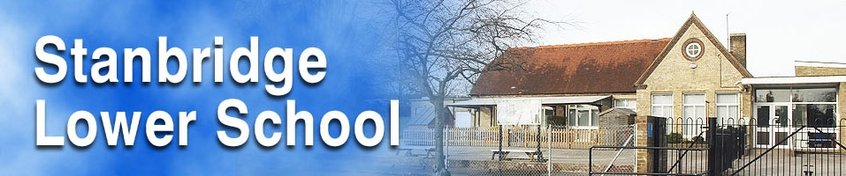

Teacher: Mrs Forbes

Year Group: Two

Term: Spring 2

Academic Year: 2022-2023

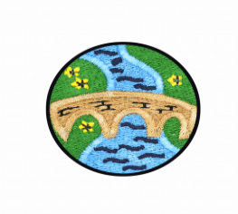

**Castles, Dragons and Knights!**

Simmering Starter:

The children will design their own coats of arms. They will use a range of different media including materials, paints and glitter to decorate their own designs. These will then be displayed on our new topic board.

Grand Finale:

The children will create a class book surrounding the new topic of Castles, Dragons and Knights. They will each record facts that they have learnt from across the topic areas and these will be put together to create a book. The children will hopefully, also go on a school trip to ‘Windsor Castle’ to learn how to become a knight!

DT:

**Topic: Food technology!**

This half term, the children will develop a range of skills involving preparing, chopping and making a range of different foods. They will learn about the importance of food and personal hygiene and how to prepare food carefully. They will make a range of different dishes and some of these will be themed around our new topic!

History:

**Topic: Changes beyond living memory (Castles + Knights)**

In this topic, the children will be learning about some important historic castles, the main features of these castles and their location. They will learn about the role of a ‘knight’ and their importance for protecting the castles, communities and serving the ‘King’ or ‘Queen’ at the time. The children will also explore different myths and legends and key ‘historic battles’ that took place and why (Invasion of England and the Battle of Hastings).

Within these lessons the children will take part in a lot of fun and practical activities including acting/drama, role-playing as different knights and creating their own model castles.

Music:

**Topic: Myths and Legends!**

In this topic, the children will create their own layered and graphic scores based around myths and legends (King Arthur and Orpheus and Euridice). They will also create their rhythms to represent the story of George and the Dragon. The children will spend time composing with structure, rehearsing and finally performing their compositions.

PSHCE:

**Topic: Relationships (part two)!**

In this topic, the children will learn about people who are special to them and how we can help others. They will learn about appropriate and inappropriate behaviour and that both our bodies and feelings can be hurt. They will also explore that hurtful teasing and bullying is wrong and what to do if this ever happens to themselves or others.

Geography:

**Topic: Where are the castles in the UK?**

This half term, the children will identify the UK on a world map and the countries that make up the United Kingdom. They will name and locate the capital cities. The children will also identify the land features that each capital city castle has been built on or near and begin to think about which geographical features made people decide to live near a castle.

Religious Education:

**Topic: What is the ‘Good news’ Jesus brings?**

The children will be learning about some stories from the Bible and making connections between the concept of ‘Gospel’ and ‘Good news’. They will discuss what these stories mean to Christians and how they believe that Jesus instructed people on how to behave. They will learn to give examples of ways in which Christians follow the teachings studied about forgiveness and peace and bringing good news to the friendless. The children will also consider ways in which Christians put these beliefs into practice in the Church community and their own lives. We will think, talk and ask questions about whether Jesus’ ‘good news’ is only good news for Christians, or if there are things for anyone to learn about how to live, giving a good reason for their ideas.

Physical Education:

**Topic: Invasion Games + Dance!**

In this topic, the children will continue to develop their passing, attacking and defending skills in a range of different games. They will carry on learning how to use space to their advantage and how to intercept a ball by entering another person’s space within a game.

They will also take part in a sequence of dance lessons, which are inspired by fantasy stories (medieval theme). These lessons follow a narrative structure which surrounds ‘a hunt to find a dragon, the legend of Arthur, The Sword in the stone and the story of Robin Hood).

Science:

**Topic: Living things and their habitats + Plants**

This half term, the children will explore and develop their understanding of the life cycle of plants and what time of year that they grow the best and why.

The children will explore outside, and through observation, the differences between things that are living, dead, and have never been alive.

We will discuss the features of those things that are living, dead and have never been alive.

We will explore the school grounds on the hunt for microhabitats. Zoom in on the tiny world of these habitats and draw or photograph what is going on there. The children will consider and draw conclusions about what lives in these microhabitats and why.

Art:

**Topic: Castles**

The children will also be working on a class designing castle flags.

The children will design their own coats of arms. They will use a range of different media including materials, paints and glitter to decorate their own designs. These will then be displayed on our new topic board.

Computing:

**Topic: Copywrite!**

In this topic, the children will be learning about what ‘Copywrite’ is and the importance of naming, dating and saving their own work to avoid ‘Copywrite’. They will recognise how to insert images into their own work which do not have a ‘Copywrite’. The children will create their class book on the laptops and will record what they have learnt by changing the different fonts, colours and styles on the application ‘Microsoft word’. They will then save, date and print off their work to create our class book surrounding Castles, Dragons and Knights!

**Computing**

Simmering Starter:

The children will step back in time and play in the role of the evacuees from the World War II. They will climb aboard a ‘train’ with their ‘ID cards’ and make their way to ‘Devon’ and embrace themselves within a full virtual experience, which will replicate how things were for the children during the war (as closely as possible). They will describe their emotions and feelings relating to leaving their parents behind and how it must have felt being chosen (or not) by another family and having to leave their old lives behind them.