

Class Letter – Year 2
Spring Term 1 2023

Learning News | This half term we are learning about; History and Geogrpahy: Stanbridge Now and Then Science: Animals including humans , PSHCE: Relationships, British Values: Mutual respect, tolerance and diversity , Design and technology: Music: British songs and sounds , PE: Athletics and Dance, Computing: Digital creativity + E-Safety, Religious education: What makes an inspiring person and what stories  inspire Christians?
Gaps in Learning | English: Phonics Writing  Maths: Money  The children should be able to recognise coins based on their real-life experience, as well as earlier learning in Year 1, but may need a quick recap on each coin and its value. They should be able to recognise both notes and coins based on their real-life experience, as well as earlier learning in Year 1, but may need a quick recap on each note or coin and its value. Children will represent amounts using “and”, for example £5 and 30p, rather than £5.30. Children select notes and coins from a bigger set, reinforcing their learning on counting money as a method of checking their answers. Children could start by making the amount in one way, before swapping notes/coins for other notes/coins that make the same value. For example, they could swap a 20p coin for two 10p coins to make the same amount. When finding the total, children should be encouraged to consider different methods such as counting on, partitioning and regrouping.  Multiplication and Division  In this block, children make the connection between repeated addition and multiplication. In this small step, they start to make this connection by recognising equal groups. Children begin this step by identifying equal groups and matching equal groups to numerals and words. As children have already learnt to add three 1-digit numbers, they should be able to add up to three groups of any 1-digit number. If there are more than three groups, children can use their understanding of counting in 2s, 3s, 5s and 10s to find the total. Children should use pictures to support understanding and the language of “lots of” and “multiplied by”. These should be used alongside the multiplication symbol to help develop children’s familiarity with the symbol. Children identify the multiplication number sentences and draw pictures that represent them or express them as word problems.
  Year 1  Spring 1 | Phase 5 graphemes | Common Exception Words | 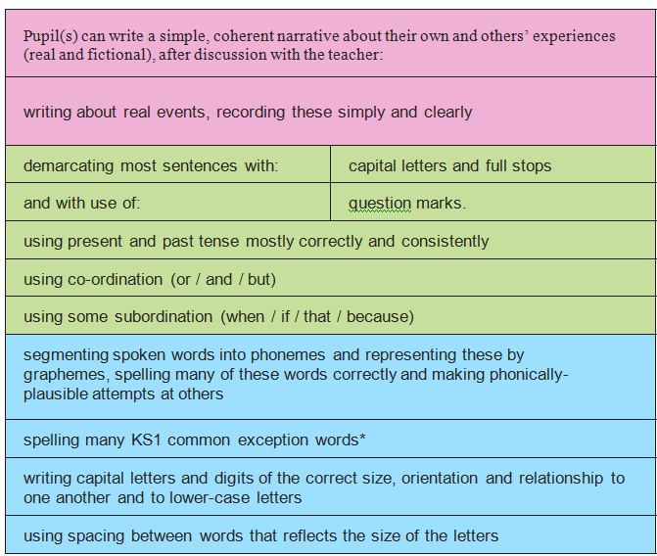
  Week 1 | Review the /or/ sound spelt or and ore  Review the /or/ sound spelt aw and au  Review the /l/ sound spelt l and ll | Year 2- spelling and reading of all year 2 Common Exception Words within spelling sessions and dictation.
  Week 2 | Review the /ar/ sound spelt ar  Review the /ar/ sound spelt are  Review the /air/ sound spelt air or ear
  Week 3 | Review the /ear/ sound spelt ear  Review the /e/ sound spelt ea  Homophones
  Week 4 | Review adding the suffix –est with no change to the root word  Teach irregular plurals  Teach plurals of words ending y
  Week 5 | Review compound words  Review adding the prefix un-  Review nouns, adjectives, verbs and adverbs
  Week 6 | Teach adding –ed to words ending e  Teach adding –ing to words ending e  Teach adding –er or –est to words ending e
Good News | During the first week back, the Year 2 pupils have written letters to the fairies of the Enchanted Wood and are looking forward to reading their replies. If you have any fairy related story books at home, you are welcome to bring them in to share during story-time.  We will be having a visit from the Leighton Buzzard firefighters and they will be teaching us about fire-safety.
Homework | Homework will continue with the same format as last term. The only slight difference is that they will now be practicing the 5x table on TTRS for this half term. Please make sure your child does not do the ‘gig’ session at home. This is something we do in school every 4 weeks to monitor their progress.
PE Kits | PE will be indoors for this half term. Children need shorts and a t-shirt.
Forest Schools | Ensure your child has a warm coat, hat and gloves in school during colder weather.
Library | Library books will be changed weekly and are to enjoy at home with an adult or sibling.
****PLEASE MAKE SURE YOUR CHILD BRINGS IN THEIR READING BOOKS EACH FRIDAY TO CHANGE****
****PLEASE MAKE SURE YOUR CHILD BRINGS IN THEIR MATHS HOMEWORK EACH MONDAY FOR US TO MARK AND PROVIDE THE NEXT PIECE OF HOMEWORK****

