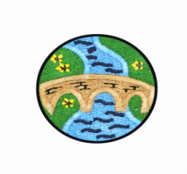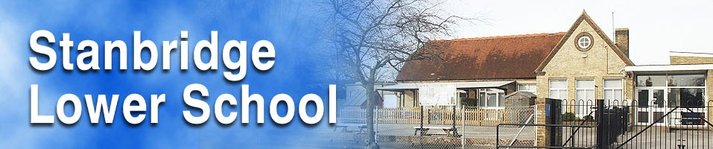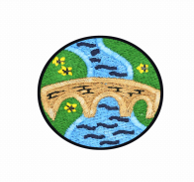

Teacher: Mrs Turney

Year Group: 3

Term: Spring 1

Academic Year: 22/23

**RIVERS & EGYPT**



**Computing and E Safety**

This half term our focus in Computing will be ‘Managing Online Information’. As we research our topic of rivers online the children will learn how to:

* Use a browser address bar.
* Understand autocomplete and be able to choose the best suggestion.
* Explain the difference between a ‘belief’, an ‘opinion’ and a ‘fact’.
* Talk about the history of the internet and explain what a network is.

**Grand Finale:**

Our very own Egyptian display of all the wonderful things we have completed over the term.

**Simmering Starter:**

An exciting story describing the incredible journey Rosie Raindrop took from the River Thames all the way to the North Sea. 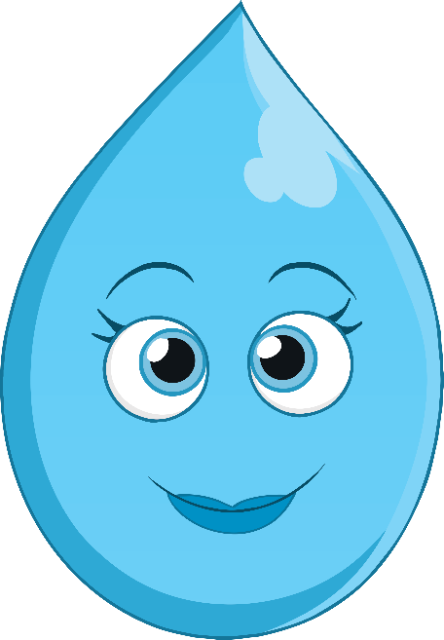

**Art**

As we continue our topic on Egypt we will look at hieroglyphics and the children will learn to sketch some of the symbols.

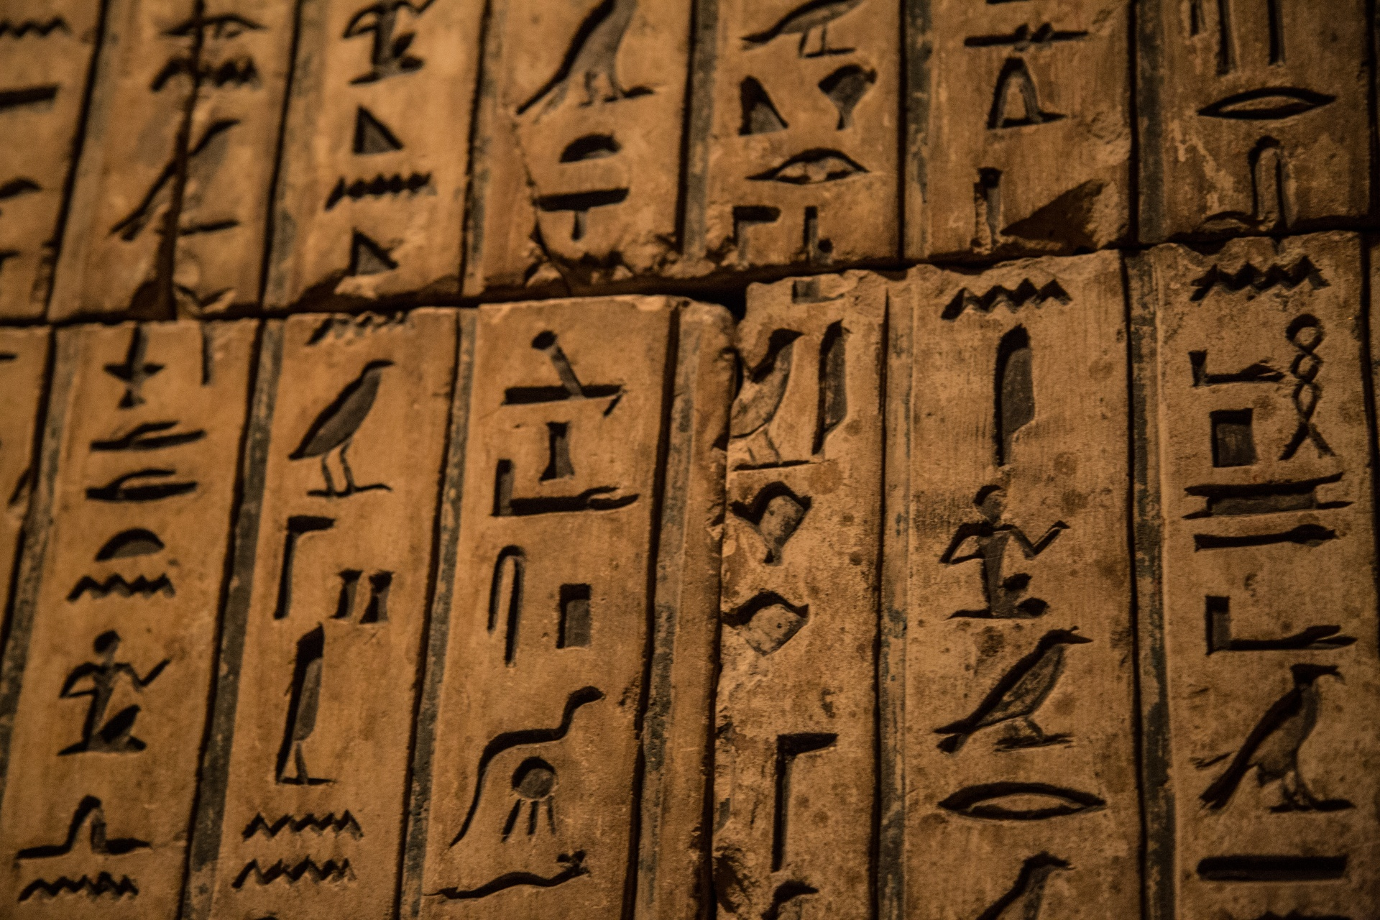

We will then investigate the importance of a cartouche in ancient Egypt. The children will design their own and make it out of clay.

**Science**

In Science this term children will discover and investigate the different types of rocks and how they are formed. Children will compare and group rocks based on appearance and simple properties. They will learn how fossils are formed and learn about the contribution of Mary Anning to the exciting field of Palaeontology.

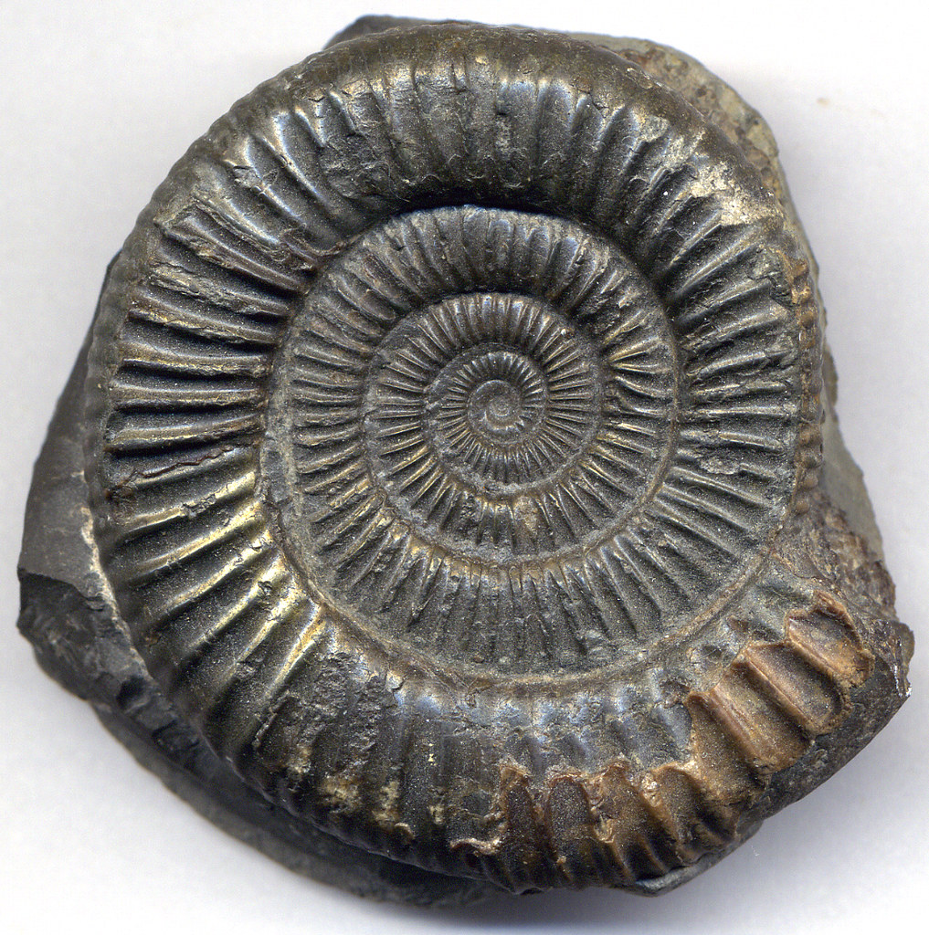

Children will also understand how soil is formed and then investigate the permeability of different types of soil.

**Geography**

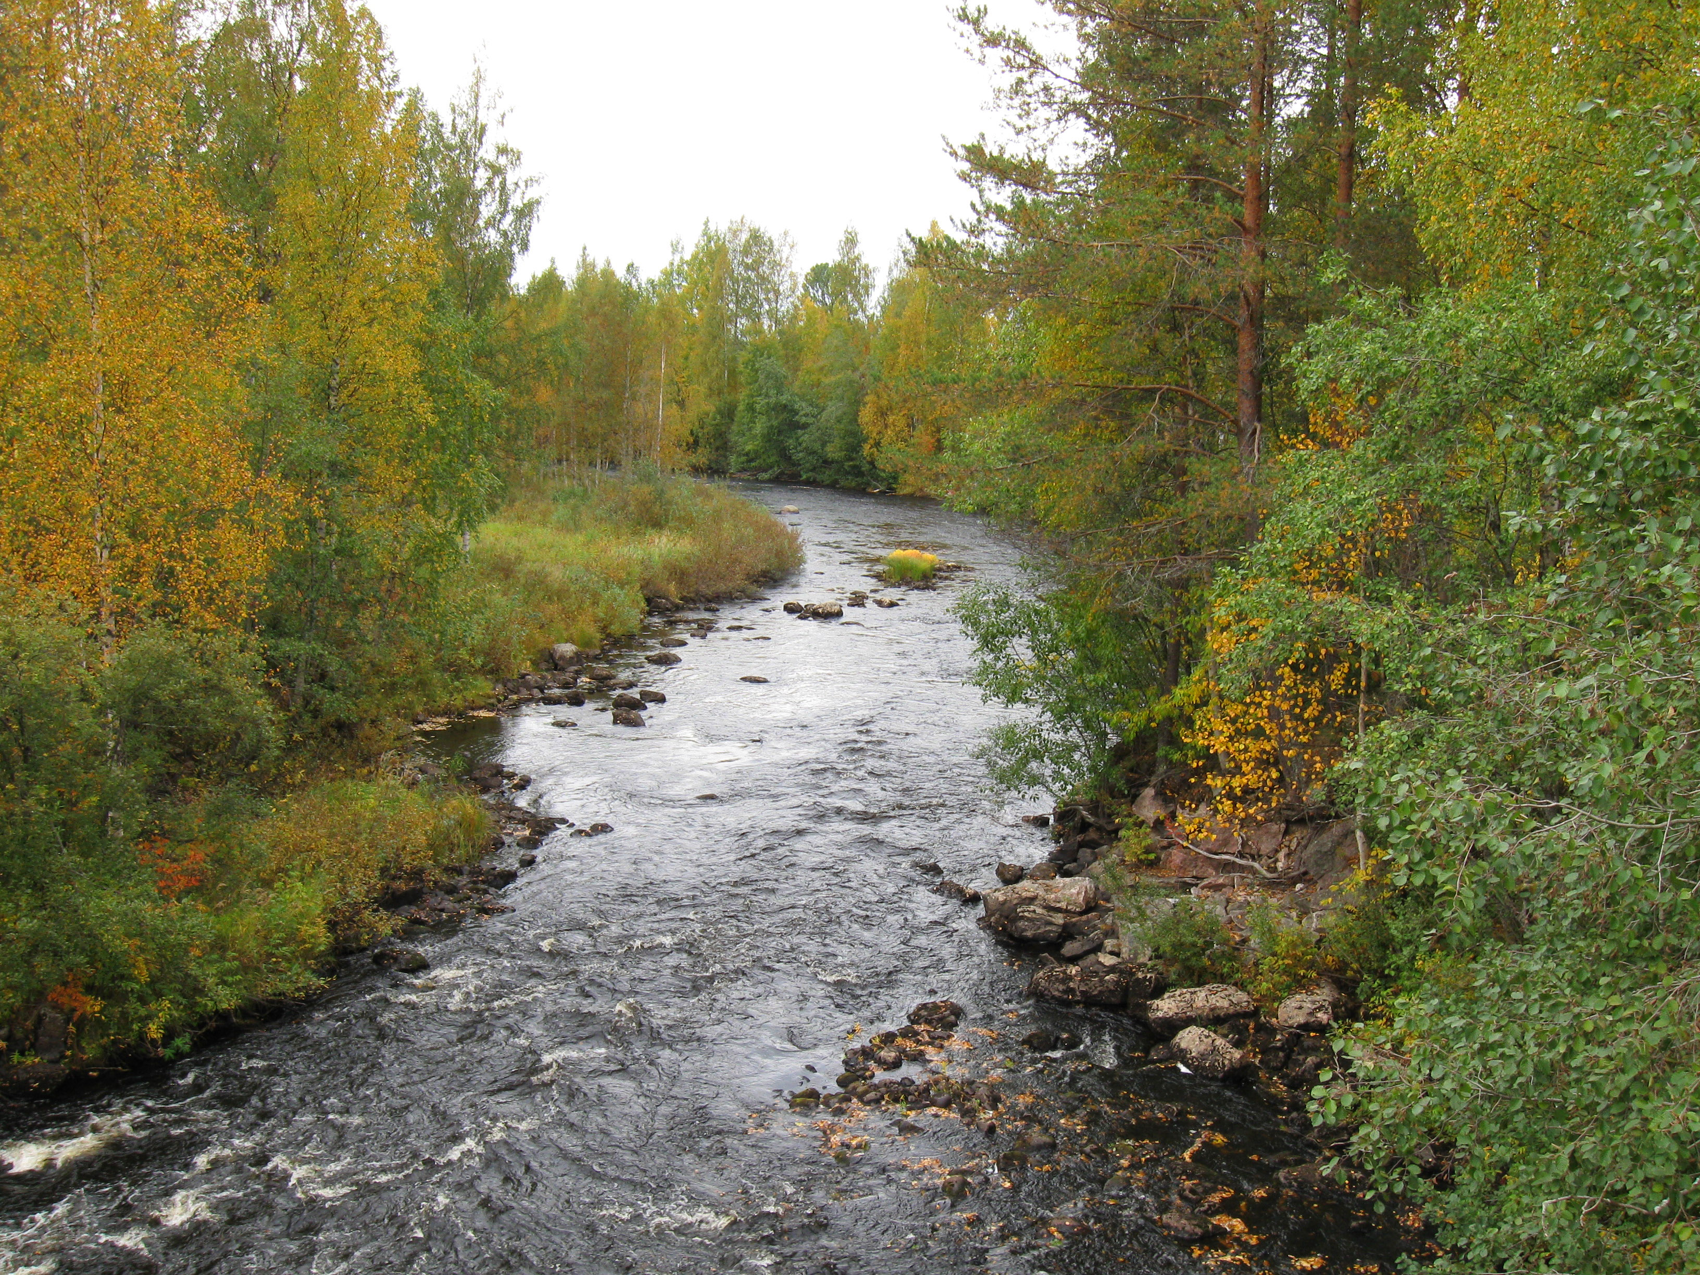

This half term the children will look at the physical and human features of a river. We will start by looking at the journey a river makes from the hills to the sea, and then learn to identify parts of a river system. We will continue our topic investigating the River Nile and its importance in ancient Egypt and life today.

**French**

This term our French lessons are ‘food’ themed. We will enjoy an easy-to-follow story as our inspiration and this will pick up and develop our learning from last term. By joining in with the story of ‘The Very Greedy Dog’, the children will learn the vocabulary for a range of food, to express likes and dislikes, and to count and use plural nouns.

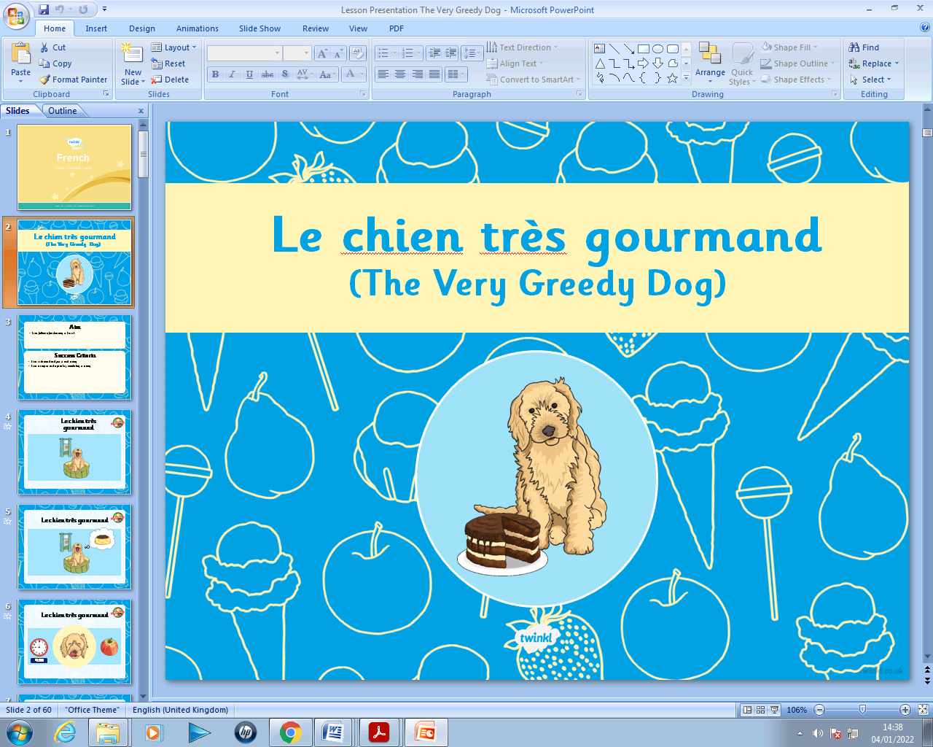

**PE**

This half term our focus in PE will be dance and gymnastics.

The children will learn a dance based around our theme of Egypt where they will learn a range of movement patterns and choreograph it to music.

In gymnastics the children will participate in jumps, shapes, balances and rolls. They will learn to perform more complex sequences using smooth transitions from movement to movement. These sequences will also have elements of flow using dynamics such as fast and slow.

**History**

What can we find out about

ancient Egypt?

During this topic the children will become familiar with the ancient Egyptian civilisation. From mummification to the River Nile, we will find out all about life in ancient Egypt and what we can learn from the evidence the ancient Egyptians left behind.

**DT**

As part of our topic on ancient Egypt the children will be researching, designing and making their own Egyptian mask.

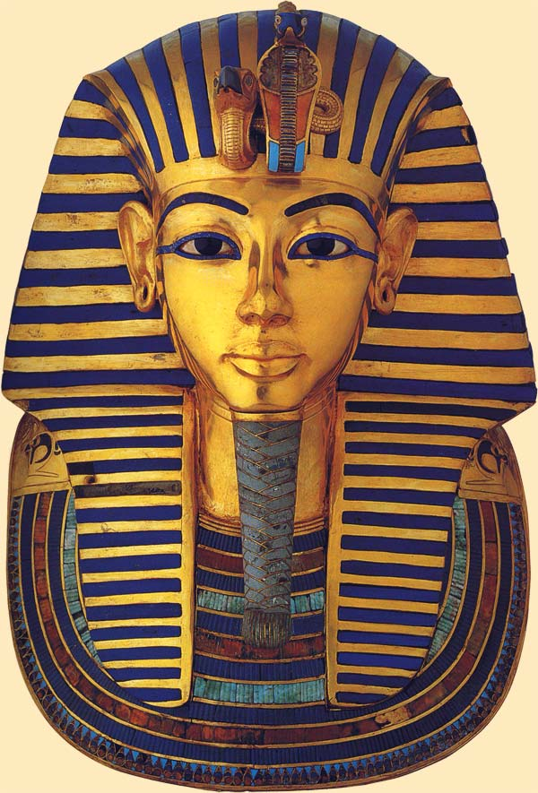

**Music**

This term the children will enjoy lessons delivered by Inspiring Music. We will be learning to play the wind instrument called the ‘ukulele’.

**PSHCE**

**RE**