

**Opportunity to ask questions, gain information, advice,**

**and guidance on Internet safety**

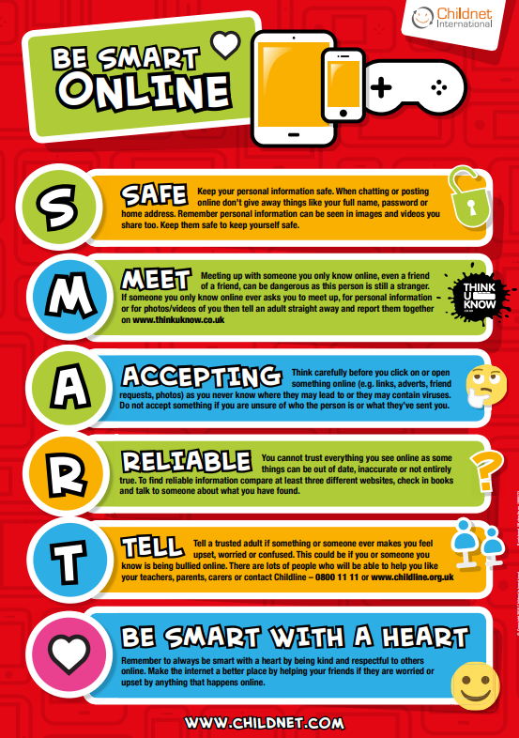

**Guest Speaker**

**Sally Simmonds Education and Diversion PCSO**

**Professional session Thursday 9th February 2023**

**11-12pm**

**Free to attend via Microsoft Teams**

[**https://www.eventbrite.co.uk/e/478155194057**](https://www.eventbrite.co.uk/e/478155194057)

**Register for you place via the Eventbrite link below**

**Resources will be sent out after each session**

**This session is for professionals only**

**Professional Insight**

**Gain information, support, and guidance every month**

**Early Help Team**