

Tilsworth Road
Stanbridge
LU7 9HY
01525 210328
Email: info@stanbridge.beds.sch.uk

Newsletter No8
6th December 2022

Dear Parents

After lots of thought and consideration, I have made the heartfelt decision to retire as Head Teacher of Stanbridge Lower School.

I have thoroughly enjoyed my time as Head and this has been a very long and hard decision to make, as I have loved working at Stanbridge helping the children to learn and succeed and supporting Stanbridge families. This has been a huge part of my life and career. I will be here for the rest of this academic year, continuing to work to ensure Stanbridge is part of the community and a place where children and families love to be. I will retire at the end of the summer term 2023.

The governors are working with the local authority who are all committed to finding another head teacher who fits our ethos and values at Stanbridge, understanding this will be a big change for all the Stanbridge community; children, parents and staff. This transition will be made as smooth as possible enabling the new head teacher to lead the school into a new and exciting phase.

The position will be advertised within the next week and interviews will be held in the New Year. The governors will keep you all informed and introduce you to the new head teacher in due course.

I remain committed to caring for your children, supporting families and leading teaching at learning at Stanbridge until I retire. If anyone has any concerns or questions, please do come and speak to me.

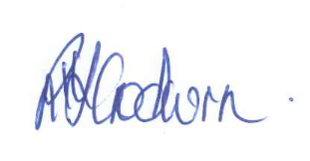
R J Godwin
Head Teacher

