

Teacher: From All Teachers

Year Group: All Year Groups

Week beginning: 12.12.22

**Home Learning Grid**

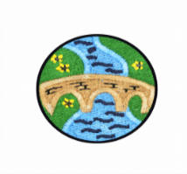

**Maths**

Years 2,3,4 Complete Times Table Rock Stars.

Yr 1, 2 see Winter Activities Addition and Subtraction Sheets.

Yr 3, 4 See Winter Challenge Cards.

**English**

**All children**

**Spelling:**

1. Please complete your weekly spellings.

2. Use the spellings to make silly sentences.

**Writing:**

Write a story all about Christmas or use these story starters to help you or create your own.

*The snow fell heavily all around me and all I could hear was the patter of little feet…….*

***Or***

*Crunch, crunch, crunch went Santa’s boots as he…………*

**PE**

**All children**

Build a snowman in the snow.

Can you add a carrot nose, button eyes and a hat?

Take a picture of your snowman.

**Reading**

**All children**

Read your reading book

Yr 2,3,4

Write a book review about your book.

What can you tell us about the setting, characters, plot?

**Art**

**All children**

Draw, paint or collage a Winter scene.

Make some paper chains out of any paper, even newspaper, to bring into school to hang in your classroom.