Parent Space  A free, virtual drop in for parents | 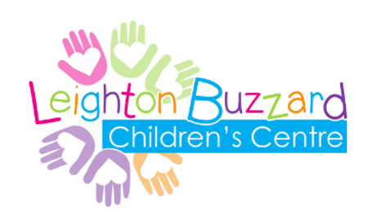

  - Every Thursday
  - 11am-12pm

  - This is a drop in for parents, organised by the Early Help team at Central Bedfordshire Council, alongside support from Leighton Buzzard Children’s Centre and Groundworks.

  - Why not grab yourself a tea or coffee and join us to hear about what support is available to you, chat with other parents and ask us any questions.

  - On the 1st Thursday of every month will we have information on a number of different topics.

  - Thursday 3rd March – Emotional Wellbeing Support for Parents – MIND Services

  - This drop in will take place virtually, via Microsoft Teams. You will need to download the free Microsoft Teams app and join the drop in using the link which will be emailed to you.

  - Please email Amanda.McDonald@centralbedfordshire.gov.uk
  - if you would like to join.

