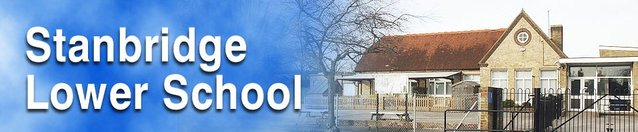New Starter Form

UPN |  | Year Group | Date of Birth Proof Seen Yes/No
Surname | First Name |  | Middle Name | Known as M/F
Address

Post Code

Home Telephone no Email
First contact in an emergency

Name Relationship to child No:

Additional contacts

Name Relationship to child No:

Name Relationship to child No:

Please list the last School/Nursery that your child has attended

Date of Leaving Reason for Leaving
Please indicate whether your child will be having either:
Universal Free School Meal ..... Paid School Lunch .... Packed Lunch .....
( Reception, Year 1, Year 2)

School Lunch Provided due to Parent being ......
In receipt of applicable benefits

Ethnic Origin
White Asian or Asian British

British .... Indian .....
Irish .... Pakistani ....
Traveller of Irish Heritage ..... Bangladeshi .....
Gypsy/Roma ..... Any other Asian background ...
Any other White background ....
Mixed Black or Black British
White and Black Caribbean ....Caribbean ......
White and Black African ..... African ......
White and Asian .....
Any other mixed background ....

Any other background ..................................................

I do not wish an ethnic background to be recorded
Religion | Language spoken at home
Please indicate how your child travels to school
Car/Van .....Walk .....Bicycle ..... School Bus ...... Public Bus .......

Doctors Name (GP) Dentists Name

Surgery Address Practice Address

Phone No. Phone No.
Please give us information on any serious illness relating to this child:
e.g. Asthma, Eczema, Heart conditions, Epilepsy. Food Allergies, Toilet Problems etc.
Does your child have any difficulties with any of the following:

Hearing .....Eyesight ......Speech .......Movement .........

Do you have any concerns about your child? yes/no

Are there any particular home circumstances which we need to be aware of yes/no
Is there anything else you would like to tell us about your child? yes/no

If yes would you like to speak to us confidentially? yes/no

Is your child taking regular medication which will need to be administered in school yes/no
If yes please provide details:

Permission to call a doctor: yes/no

Permission to administer First Aid: yes/no

Agency/Community Links

Are you receiving any support from:

Social Services ... Child and Family Support .... Speech Therapist .... Health Visitor ...

Any Other Community Service ..... Please give details

Are you in receipt of any benefits yes/no
Visits
I the Parent/Guardian of ......................................................HEREBY CONSENT to him/her taking part in educational visits on foot from time to time. You will be advised of all visits in advance and be required to give additional permission if the visit involves using any form of transport.

Signed...............................................................................Date............................................
Photography
Sometimes photographs are taken in school for the following purposes:
. To record the progress your child makes
. To support learning particularly in the area of Communication, Language and Literacy
. To be used in displays around the school
. To be published in Local Newspapers or displayed on our website.

I/we give permission for photographs to be taken in school and used for the purposes stated above.

Signed (Parent/Guardian)...............................................................................Date..............

